Microcontrollers Practice Manual

Digital Inputs and outputs
Description: Design and built two PCBs.
- In the first PCB the student will place 8 led’s which will be useful to see the outputs coming from a digital circuit.
- The second PCB will have a dip-switch of 8 positions in order to write information to a digital circuit.
Both PCBs should be designed for working with high and low logic voltages of 5 V and 0 V respectively. See the following figures for reference.

Figure 1. Digital Outputs.
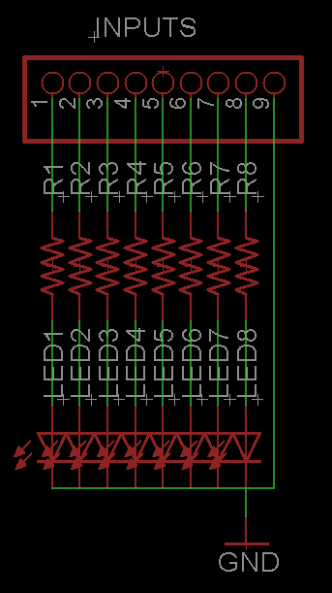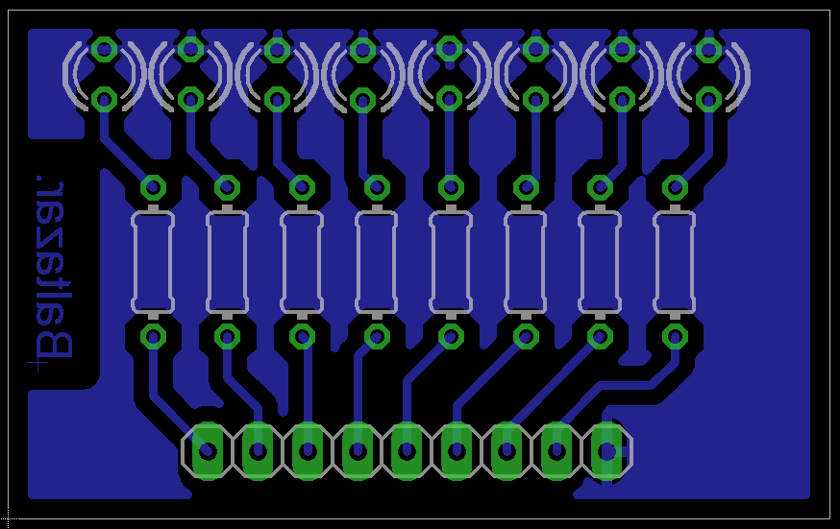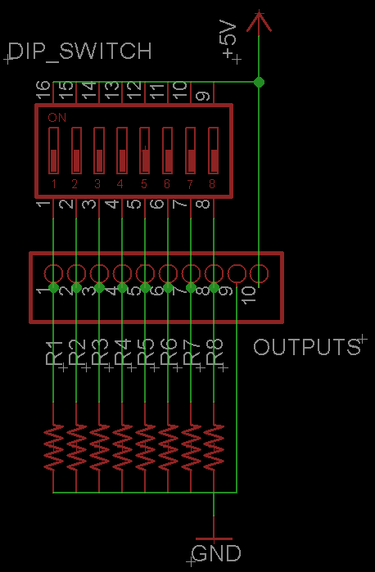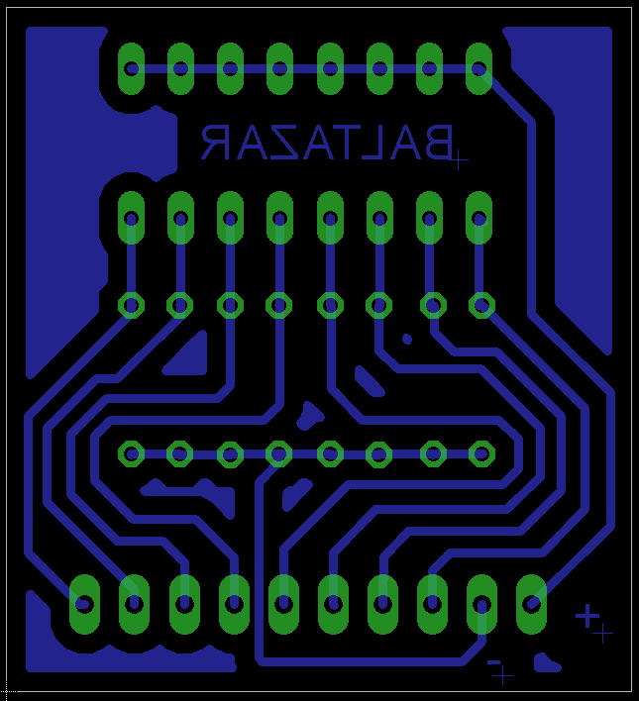
Figure 2. Digital Inputs.

How to program a DsPIC30F
What are these files for?
- *.inc
- *.asm
- *.s
- *.gld
- *.hex
A source file may contain up to four types of information. Explain:
- • Labels
- • Mnemonics, Directives and Macros
- • Operands
- • Comments
Create a Basic “dalay” routine for this times:
- 10 us
- 100 us
- 10 ms
- 200 ms
- General function “delay_10us” and “delay_ms”. The programmer should load the specific time in WREG0

Led Animations
Using the first byte of PORTB as outputs and PORTD as inputs, as described in figure 3, design the code for these options:
- Knight rider. with a delay of 100 ms
- Blink with 200 ms of delay. T = 400 ms.
- Blink with 500 ms of delay. T = 1 s
- Shift left With a delay of 100 ms
- Shift right With a delay of 100 ms
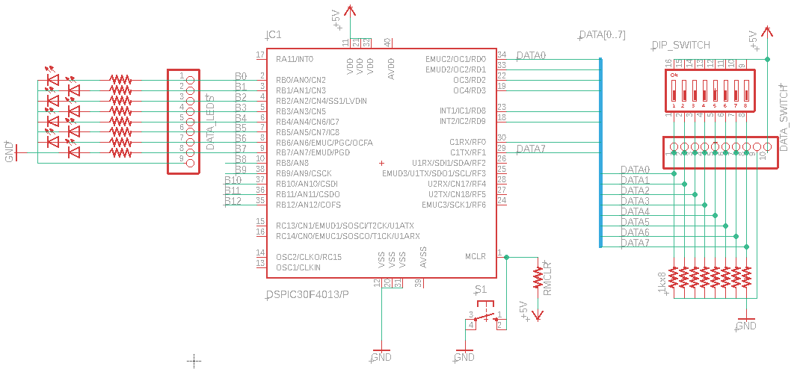
Figure 3 Circuit for dsPIC30F4013

Program memory
Using the program Memory, write the code for the same animations as in part number 3: Led animations.
You should use TBLPAG and TBLRDL .

Interrupts
  - Write the code to display in PortB the effect: knight Rider normally. In the case that there is an external interrupt 0, blink all portB three times.
  - Write the code to display the same animations as in part number 3 but this time using just one button. It is recommended to use the external interrupt 0 configured in a positive edge transition (POS).
(Cesar)IF0(Bit₀)
(Jesus) Directamente con el Pin a 13…
(Alex)Digital inputs

UART
a) Write the code to configure UART at 9600B/s, 8 bits, no parity, 1 stop bit.
The main code increments a counter and it is shown in PORTB and send it through uart1.
- Using a terminal like PICOCOM or XCTU, the user will type any key of a keyboard and the DsPIC will receive it showing the data in PORTB.

Uart + Bluetooth
Write the code to increment a variable and send its value wirelessly using an Hc-05 or Hc-06 module. Use your Smartphone, tablet or PC ‘s Bluetooth to visualize all data; I advise you to download any Bluetooth terminal from the app store. It is possible to program your own terminal if you like.

Timers
Create a music keyboard using TimerX.
Considerations:
- Use your smartphone as keyboard.
- You can use any Bluetooth terminal or program your own one.
- All diatonic notes of 4th octave.
- Each note will sound in a speaker connected at any pin of any available port. I suggest using a power amplifier before the speaker.
- Design your flow diagram.

Bonus: Using an ultrasonic sensor SR-04 , Generate the code for measuring distance. The result in millimeters will be seen in your smartphone.

